App Description:

1. A login page would first come up on the screen:

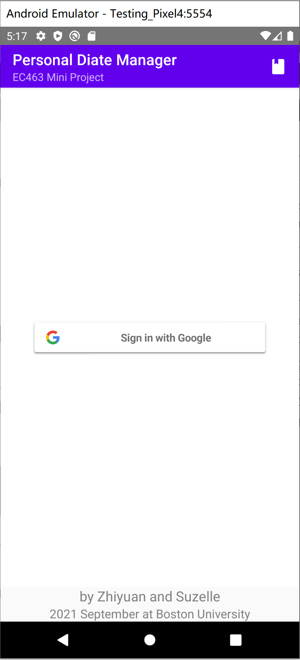

1.1 Login Page

Users can sign in using Google account, their data on this app would be upload and backed on the cloud server (firestore).

1. Main page with 3 navigation route
   1. Editing page:

Users can edit their whole-day-recipe in this page. They can create meals, add foods from their saved-food folder (also set the serving sizes), and view the nutrition summary for each meal and for the whole day.

* 1. Scanning page:

Users can scan the barcodes on the food and load the nutrition data and names of the food into their personal storage (so that they can later add the food into their recipe in the Editing page)

* 1. Saved-files page:

Users can search and view their saved foods and day recipes in this page. They can also load their saved day recipes into Editing page and continue working on it.

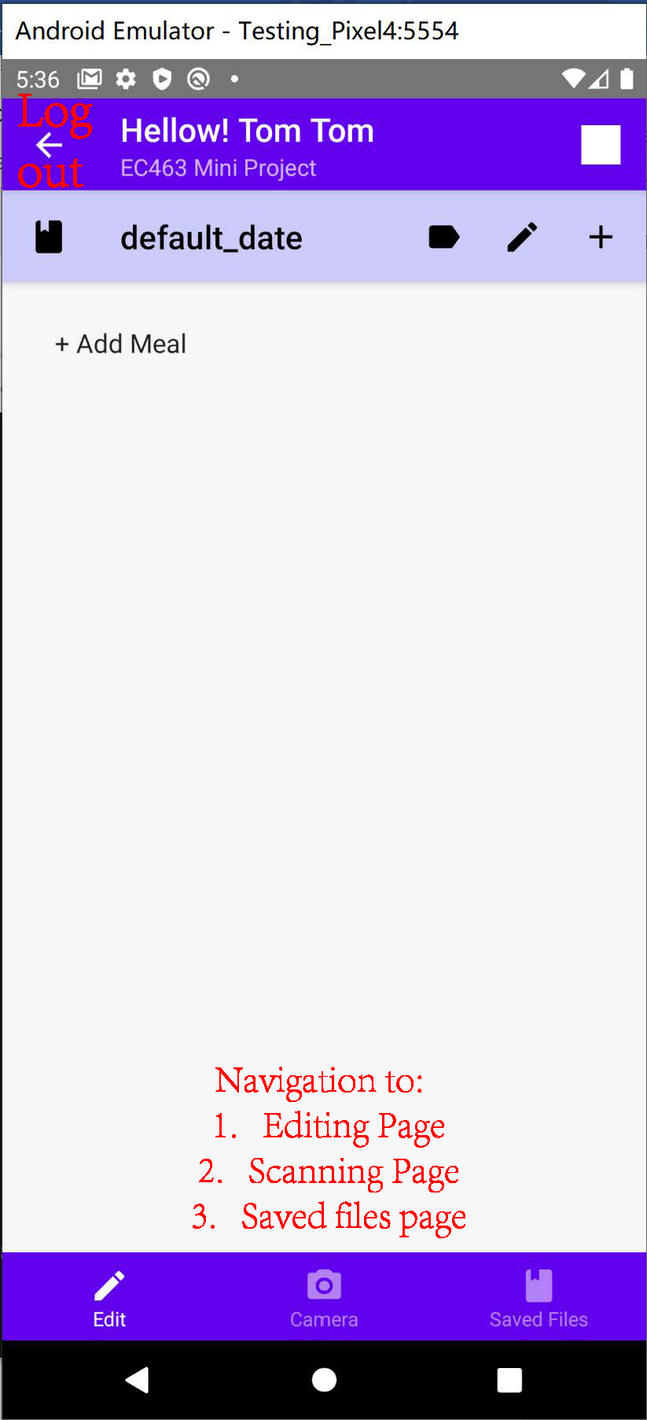

2.1 Main Page

The App bar on the top is the user name from google account, the back-arrow next to the username is the log-out button that navigates back to the log-in page.

The navigation bar on the bottom can navigate amount the three screens.

1. Editing Page
   1. User can edit/save/view the day information using the tabs on the top of the Editing Page

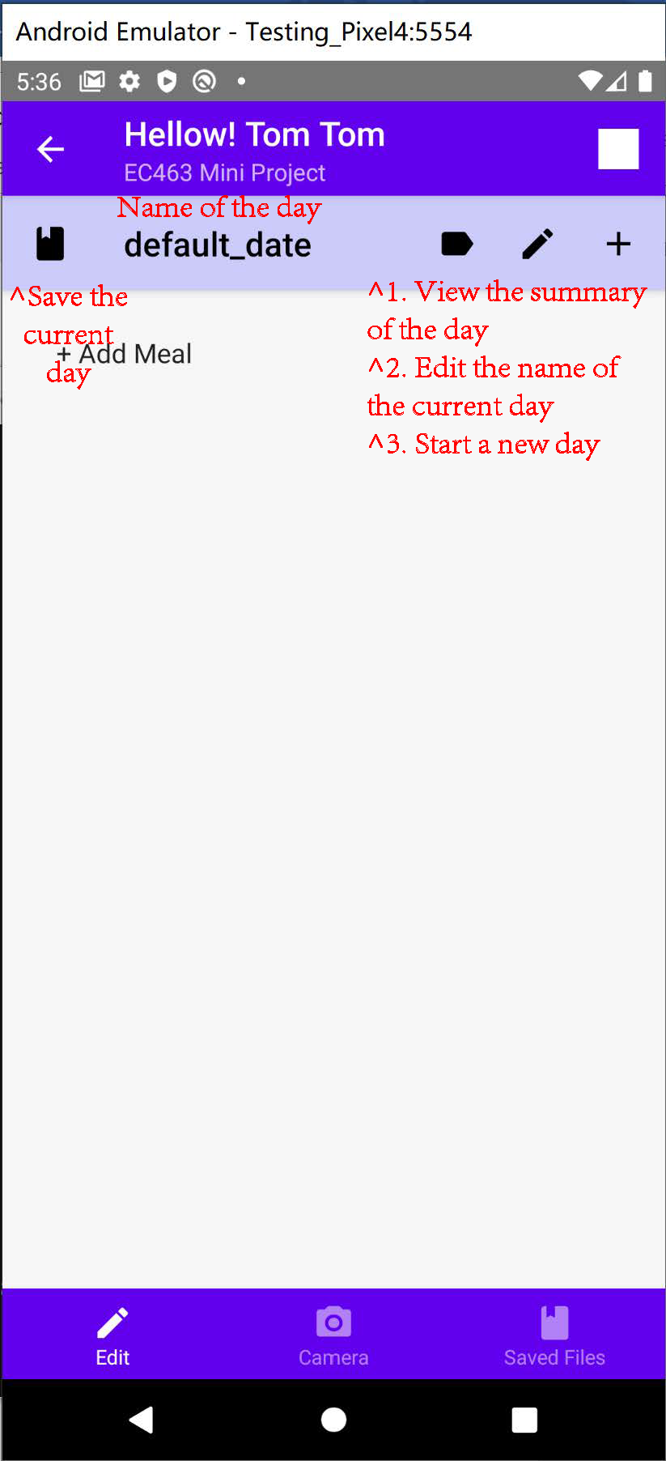

3.1.1 Day editing

* 1. User can add meal to their day recipe and add foods from their data base.
     + 1. Click “+ Add Meal” to add a new meal
       2. Click “+ Add Food” to start a food searching page and add food to the meal
       3. Single click on the meal tab to view the summary information. Long tap to edit the meal name
       4. Single click on the food tab to view the summary information. Long tap to edit the food name, serving size and the nutrition data preserving size.

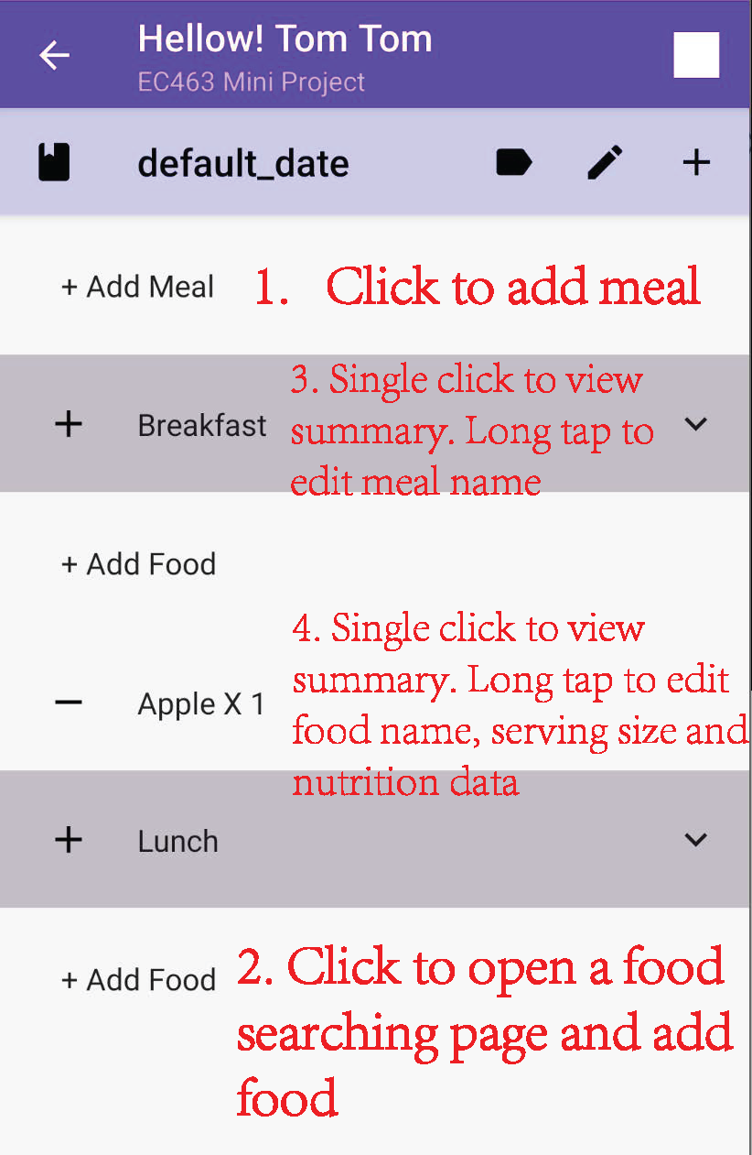

3.1.2 Meal editing

c. User can view the food/meal/day nutrition summary with a single click on the food/meal tab (for whole-day summary, click the icon right to the name of the day).

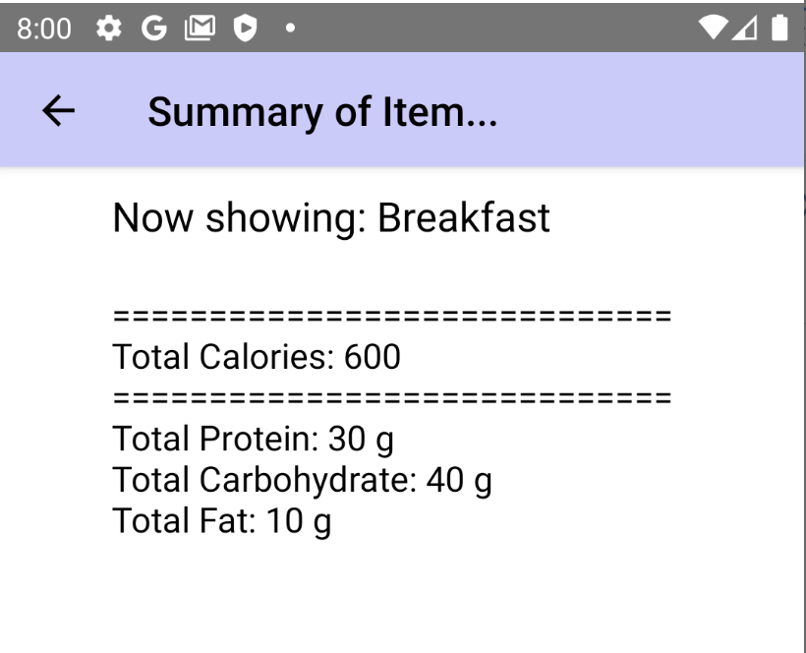

* + 1. Summary Page

1. When click the “+ Add Food” tab under a specific meal tab, a food searching page would be open and user can search for the food in their data base and add it to the specific meal.

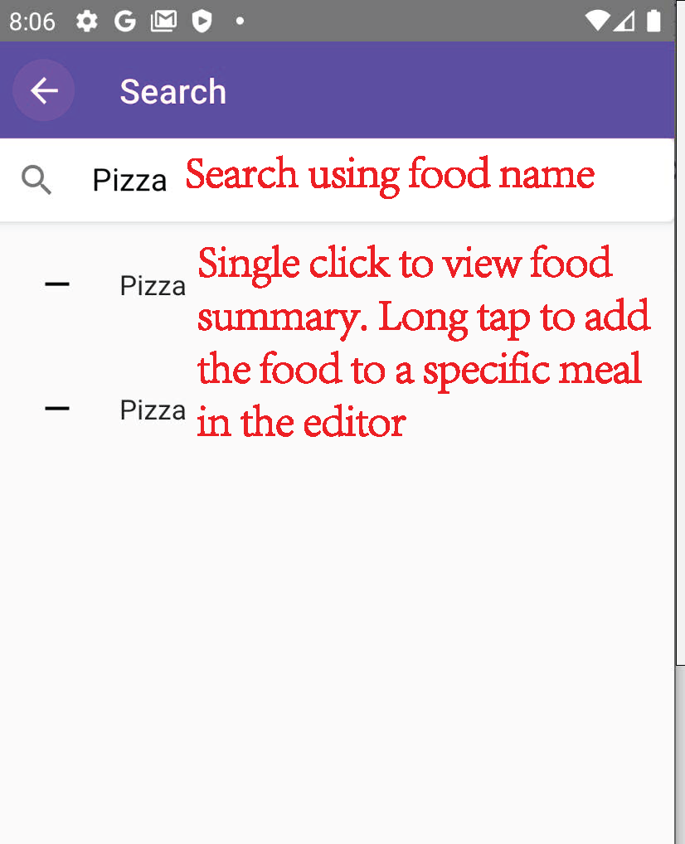

* + 1. Searching Page

1. With a Long tab on the meal/food tap in the editor page, an editing page would come up and the user can edit food’s name/serving size/nutrition information, delete the item from editor or save the item into personal database.

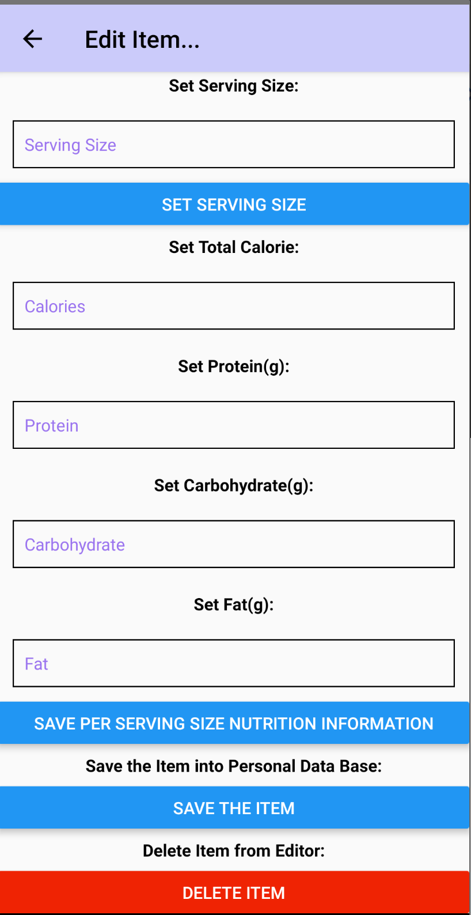

* + 1. Item Editing Page

1. Scanning Page

User can scan the barcode on the food and information of the food would be loaded by the App using FDA’s API. Food information would be saved in user’s personal database and can then be loaded in the editor (just search for the food name in the search page).

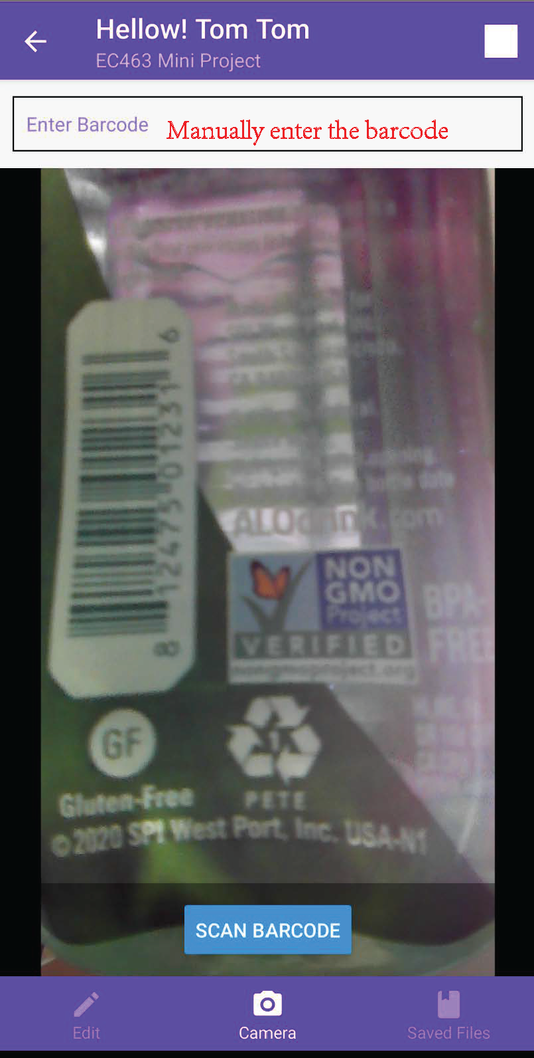

4.1 Scanning Page

1. Saved File Page

User can browse their save food/day date in the Saved File Page. A click on the “Search Saved Day-receipt/Food-receipt” tab would start a searching page similar to that one in the editor. Single click on the search result would show the nutrition summary of that day/food. A long tap on the day-receipt search result would load the day-receipt into the editor page so that the user can continue working on that day’s information.

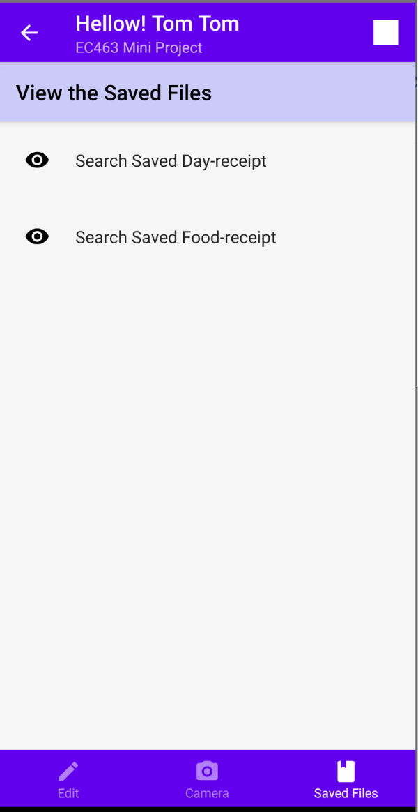

5.1 Saved File page

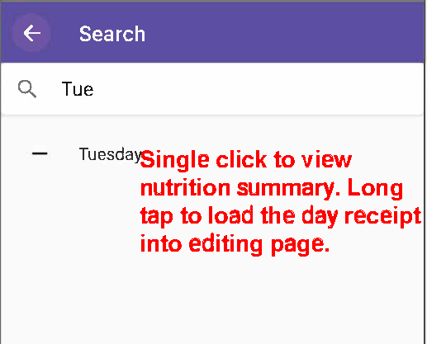

5.1 Search for a saved day receipt